
PB-T2/GEQP/1221/B 21-APR-2022
PRE BOARD EXAMINATION 3 – TERM II (2021-22)
Subject: GEOGRAPHY  Grade: XII |  | Max. Marks: 35  Time: 2Hrs

GENERAL INSTRUCTIONS-
I. Question paper is divided into 5 sections A ,B,C,D&E

II. In section A question number 1 to 3 are Very Short Answer type questions.
III. In section B question number 4 is Source based question
IV. In section C question number 5 & 6 are Short Answer based questions.
V. In section D question number 7 to 9 are Long Answer based questions.

VI .In section E question number 10 is a Map based question.
SECTION A
(VSA)
1. | Define ‘Foot loose industries. |  | 2
2. | What is Agri- business? Give an example. |  | 2
3. | Bring about any one major comparison between ‘retail and wholesale trading’ . |  | 2
 | OR
 | What are Quinary activities? Give 2 examples.
SECTION B
SOURCE BASED QUESTION
4 | Read the case study given below and answer the questions that follow:  The challenge of sustainable development requires integration of quest for economic development with environmental concerns. Traditional methods of resource use result into generating enormous quantity of waste as well as create other environmental problems. Hence, for sustainable development calls for the protection of resources for the future generations. There is an urgent need to conserve the resources. The alternative energy sources like solar power, wind, wave, geothermal energy are inexhaustible resources. These should be developed to replace the exhaustible resources. In case of metallic minerals, use of scrap metals will enable recycling of metals. Use of scrap is especially significant in metals like copper, lead and zinc in which India’s reserves are meagre. Use of substitutes for scarce metals may also reduce their consumption. Export of strategic and scarce minerals must be reduced, so that the existing reserve may be used for a longer period.
4.1 | ‘Sustainable development calls for the protection of resources. Explain |  | 1
4.2 | Why is the conservation of mineral resources important? |  | 1
4.3 | Why is scrap metal important? |  | 1
SECTION C
SHORT ANSWERS
5. | Describe the role of roads in the economic development of India. |  | 3
6. | Which is the longest trans- continental railway of North America? Write any two features of it. |  | 1+2
 | OR
 | Air Transport has made world a global village. How? Explain the significance of air transport.
SECTION D
LONG ANSWERS
7 | Discuss the significance and growth of the service sector in modern economic development. |  | 5
8 | Name the two cities which are the main polluters of river Ganga before it reaches Varanasi? Briefly explain the nature of pollution and the main polluters of these cities. |  | 5
 | OR
 | What are the impacts of rural- urban migration in India?
9 | ‘Hill Area Development Programmes in India were drawn keeping in view their topographical , ecological, social, and economic conditions’. Support this statement with suitable explanations. |  | 5
 | SECTION - E  MAP QUESTIONS |  | 2+3
10.1 | Identify the following on the political map of the world.  A. A major sea port  B. A major airport  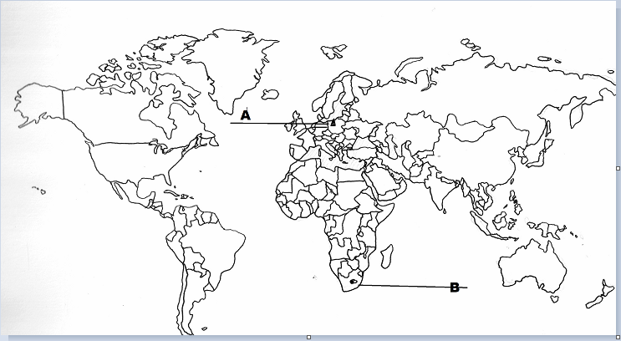
10.2 | On the outline map of India indicate and mark the following features (Attempt any 3). 1x5=5  - Iron ore mines in Karnataka  - Bokaro Coal mine  - Oil field in Gujarat  - Bilaspur bauxite mine
